CITS1501 Report

INCLUDE:
- Team members and GitHub link
- What you built and who it is for
- Architecture and data flow
- Algorithms and technical decisions
- Data source and preparation
- Analysis and visualisation
- Interface and user experience
- Testing and limitations
- Security and privacy
- Deployment
- Team contribution

PRESENTATION:
- Working application
- A realistic user task
- Important features and interactions
- An invalid input or failure case
- Our automated tests

IDEA:
Seasonal Knowledge – An app explaining Indigenous seasonal calendars and associated environmental signs

- Choose a place from the map and click the region
- It will show the seasons in that region
- Then you can click on the seasons to get info about its name, timing and seasonal indicator
- * information should include Weather patterns (shifts in wind, humidity, temp and rainfall), plant behaviour ( plants flower, fruit, shed leaves), Animal Activity (breeding cycles, egg laying, bird migrations and when animals are fat or active) and finally land and water changes (waterhole levels, soil moisture, high or low tides)
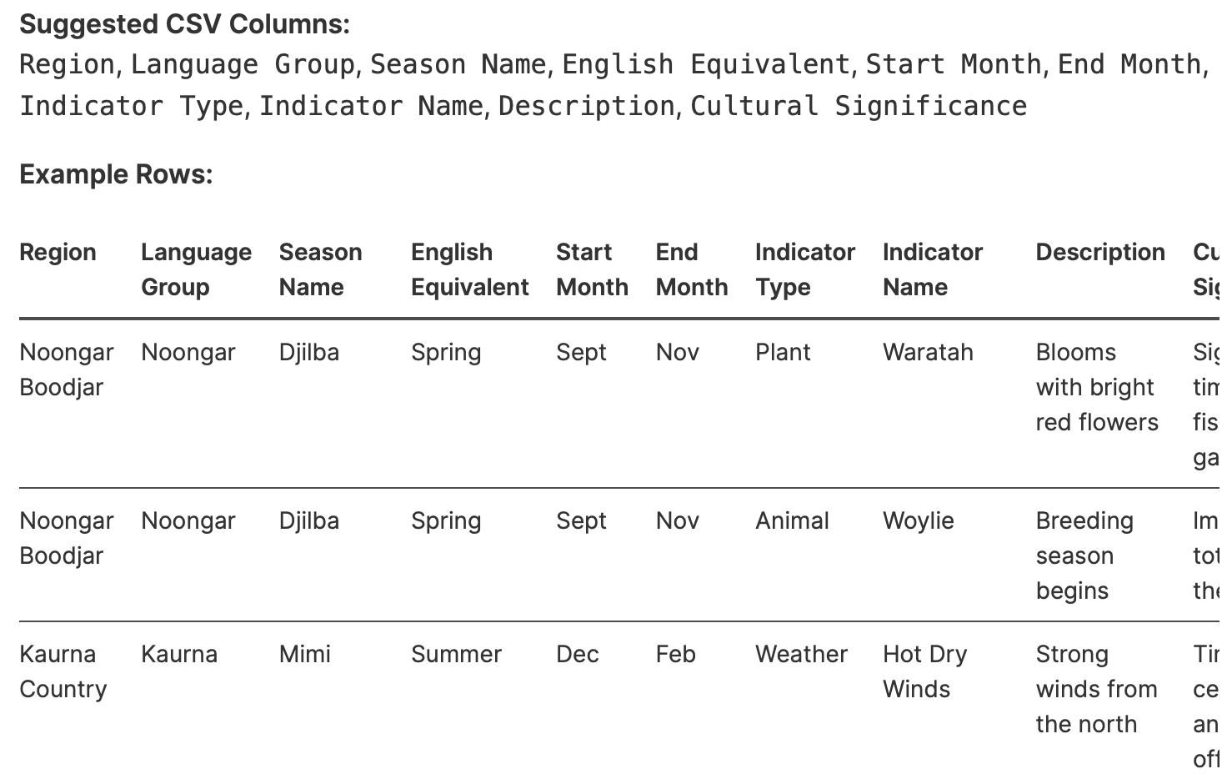

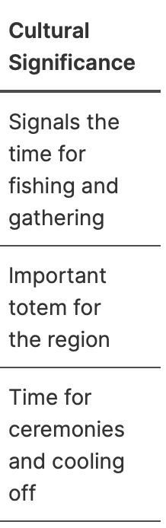

- Data set should include multiple rows of not just seasons but should instead represent a specific observation or indicator
- Indicators can be plants, animals, activities, weather patterns, etc

Data Set Sources
Aboriginal Noongar Seasons—Tourism Western Australia. (2024, November 27). Western Australia. https://www.westernaustralia.com/au/things-to-do/aboriginal-experiences/aboriginal-noongar-seasons
corporateName: [site name]. (n.d.). GESB - Noongar six seasons. (Australia). Retrieved October 4, 2026, from https://www.gesb.wa.gov.au/members/stand-alone-pages/noongar-six-seasons
Guide to the Six Noongar Seasons on Wadjemup | Rottnest Island. (n.d.). Retrieved October 4, 2026, from https://www.rottnestisland.com/visit/guides-tips/your-guide-to-the-six-noongar-seasons-on-wadjemup
Nyoongar calendar. (2021, February 8). The Bureau of Meteorology. https://www.bom.gov.au/resources/indigenous-weather-knowledge/indigenous-seasonal-calendars/nyoongar-calendar
perthnrm. (2026, October 2). The Season of Birth: Embracing Kambarang (October – November) • Perth NRM. Perth NRM. https://www.perthnrm.com/blog/2026/10/02/the-season-of-birth-embracing-kambarang/
petra. (2025, December 10). Welcome to Birak: The Season of the Young, Fire, and Action • Perth NRM. Perth NRM. https://www.perthnrm.com/blog/2025/12/10/welcome-to-birak-the-season-of-the-young-fire-and-action/
petra. (2026a, February 8). The Second Summer: Embracing Bunuru (February – March) • Perth NRM. Perth NRM. https://www.perthnrm.com/blog/2026/02/08/the-second-summer-embracing-bunuru-february-march/
petra. (2026b, March 27). The Season of Adulthood: Embracing Djeran (April – May) • Perth NRM. Perth NRM. https://www.perthnrm.com/blog/2026/03/27/the-season-of-adulthood-embracing-djeran-april-may/
petra. (2026c, May 31). The Season of Fertility: Embracing Makuru (June – July) • Perth NRM. Perth NRM. https://www.perthnrm.com/blog/2026/05/31/the-season-of-fertility-embracing-makuru-june-july/
petra. (2026d, August 1). The First Spring: Embracing Djilba (August – September) • Perth NRM. Perth NRM. https://www.perthnrm.com/blog/2026/08/01/the-first-spring-embracing-djilba-august-september/
The Six Seasons Of The Nyungar Calendar – The Wetlands Centre. (2019, December 12). https://www.thewetlandscentre.org.au/blog/the-six-seasons-of-the-nyoongar-calendar/

import pandas as pd

data = pd.read_csv("Data.csv")

# testing to see the data loaded in the correct format
print(data.head())
print("Number of records:", len(data))

seasons = data['Season_Name'].unique()
print(seasons)

I need to now start building the first part of my assignment app. The app is a Noongar Seasonal Calendar app using the Data.csv dataset that I have already imported with pandas. I want the first part of the app to be a simple home/main screen where the user can see the title of the app, a short introduction explaining what the app is about, and an interactive way to explore/select the different Noongar seasons from my dataset. I have already written code to load the CSV and get the unique season names, so please build from my existing code rather than starting again. Please inspect my existing files and dataset first, then create the first part of the app in a simple beginner-friendly way. Do not build the entire app yet just focus on creating the first screen and making sure it runs correctly. Also explain what you are doing and why as you make the changes so I can understand the code.
The first screen is built in your existing question.py, with the required packages listed in requirements.txt.
It keeps your pandas CSV loading, adds a title and introduction, and uses the dataset’s unique season names to populate a dropdown. Selecting a season shows its English equivalent, months, and observations; a second dropdown filters those observations by topic. The CSV path is based on the script’s location, so the app can find Data.csv even if you launch it from another folder.
The app is running at http://localhost:8501. To start it again later, run:
python3 -m streamlit run question.py
Verified: all six seasons appear, selecting Kambarang shows 36 observations, and filtering Birak by Weather shows 7.

what do i type in terminal to stop the session
In the terminal running Streamlit, press Control+C. You don’t need to type a command.
FIRST DRAFT OF CODE:
from pathlib import Path

import pandas as pd
import streamlit as st

data_file = Path(__file__).parent / "Data.csv"
data = pd.read_csv(data_file)
seasons = data["Season_Name"].dropna().unique().tolist()

st.set_page_config(page_title="Noongar Seasonal Calendar")

st.title("Noongar Seasonal Calendar")
st.write(
"Explore the six Noongar seasons and discover seasonal observations about "
"the weather, plants, animals, and activities recorded in this dataset."
)

st.divider()
st.subheader("Explore the seasons")

selected_season = st.selectbox("Choose a season", seasons)
season_data = data[data["Season_Name"] == selected_season]
season_info = season_data.iloc[0]

st.header(selected_season)
st.write(season_info["English_Equivalent"].capitalize())
st.caption(f"{season_info['Start_of_month']} to {season_info['End_of_month']}")
st.write(f"{len(season_data)} seasonal observations in this dataset.")

topics = season_data["Indicator_type"].dropna().unique().tolist()
selected_topic = st.selectbox("Filter by topic", ["All topics", *topics])

if selected_topic != "All topics":
season_data = season_data[season_data["Indicator_type"] == selected_topic]

st.dataframe(
season_data[["Indicator_type", "Indicator_Name", "Description"]],
hide_index=True,
width="stretch",
)

